**Submitted To:**

**DR. SHAISTA RAIS**

**Section: A**

**5th Semester (BSCS)**

**Subject:**

**OPERATIONAL RESEARCH**

**Submitted by:**

* Noman Siddiqui, Eb21102087
* Zain Ul Rab, Eb21102134
* Muhammad Abrar Khan, Eb21102051
* Sheikh Muhammad Ezan, Eb21102103
* Hafsa Usman, Eb21102028

**Department of Computer Science - (UBIT)**

**UNIVERSITY OF KARACHI**

**OPERATIONAL RESEARCH SIMULATOR PROJECT**

**Table of Contents:**

1. Project Vision
2. Project Significance
3. Chi-square Goodness of fit test
4. Distribution proved for Inter-Arrival
5. Distribution proved for Service time

**1. Home Page**

* **1.1** Introduction to the Home Page
* **1.2** Navigating Through the Home Page

**2. Simulation of Random Data (Seconds/Minutes)**

* **2.1** Overview of Simulation
* **2.2** Configuring the Simulation
* **2.2.1** Time Unit Selection
* **2.2.2** Queuing Model Selection
* **2.2.3** Input Parameters for Models
* **2.3**  Executing the Simulation
* **2.4** Interpreting Simulation Outputs
* **2.4.1** Cumulative Probability and Lookup
* **2.4.2** Interarrival and Arrival Times
* **2.4.3** Service Times
* **2.4.4** Start and End Times
* **2.4.5** Turnaround, Wait, and Response Times
* **2.4.6** Average Performance Metrics
* **2.4.7** Server Utilization and Idle Rates
* **2.4.8** Gantt Chart Visualizations

**3. Queuing System**

* **3.1** Understanding the Queuing System
* **3.2** Configuring Queuing Models
* **3.2.1** Model Selection
* **3.2.2** Input Parameters for Chosen Model
* **3.3** Initiating the Queuing Simulation
* **3.4** Analyzing Queuing System Outputs
* **3.4.1** Server Utilization Factor
* **3.4.2** Server Idle Time
* **3.4.3** Customers in Queue and Wait Time
* **3.4.4** Customers in the System and Wait Time

**4.** Summary

**5.** Conclusion

1. **Project Vision:**

Our vision is to create an engaging web-based platform that replicates the operations of a real PSO-Sheikh Zayed Petrol pump. By using simulations, we aim to help users understand queuing systems better and gain practical insights into operational processes.

1. **Significance:**

This project is important because it:

* 1. Teaches users about operational research in a hands-on way.
  2. Helps users make better decisions by analyzing important metrics.
  3. Connects theoretical concepts with real-world applications.
  4. Empowers students and professionals in different fields.
  5. Promotes collaborative learning and practical experience.
  6. Demonstrates how technology can solve practical challenges.

1. 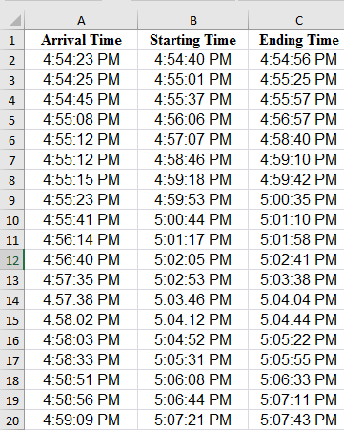**Chi-square Goodness of fit test:**

**Visual of**

**Sample Data**

**For Interarrival Time:**

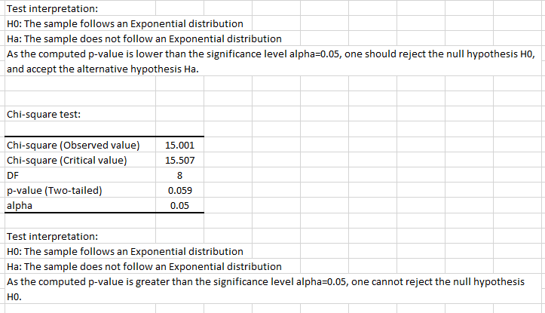

**Comparison B/w Observed and Theoretical Frequencies:**

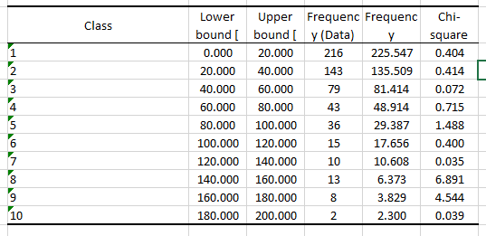

**Interpretation:**

"Through thorough analysis, we've confirmed a strong fit between our data and the expected exponential distribution. As a result, we're accepting the null hypothesis, indicating that our data aligns well with this distribution. This validates our choice of statistical model and reinforces the credibility of our approach."

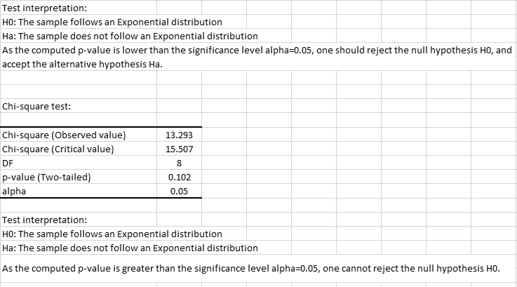**For Service time:**

**Comparison B/w Observed and Theoretical Frequencies:**

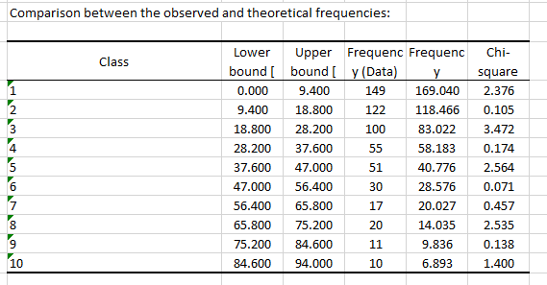

* **Interpretation:**

Our conducted analysis has rigorously validated our data's conformity with the exponential distribution model. As a result, we are opting to accept the null hypothesis, affirming that our data aligns satisfactorily with the assumed exponential distribution.

**1. Home Page:**

**1.1 Introduction to the Home Page:**

The Home Page serves as the gateway to the Operational Research Simulator Project. Designed to provide a smooth introduction, this page features the names and seat numbers of participants. Users can navigate through the application's sections—namely "Simulation of Random Data" and "Queuing System"—via the accessible sidebar.

* **Home Page** (Screen Shot)

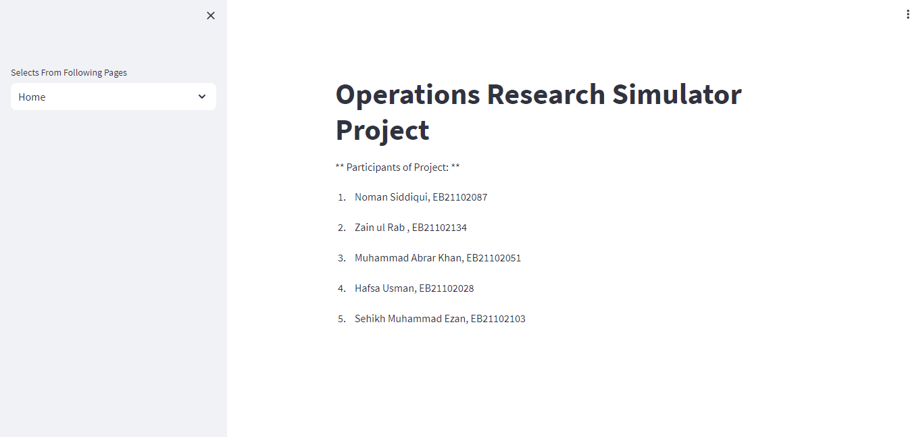

**1.2 Navigating Through the Home Page:**

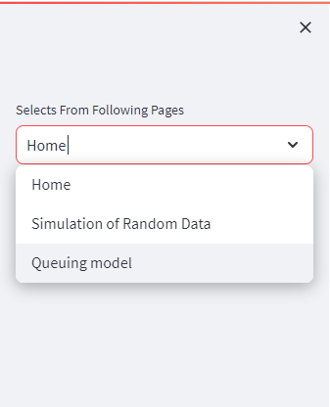From the Home Page, users can conveniently explore the simulation and queuing sections. The sidebar offers direct links to these sections, empowering users to embark on their journey through the project.

* **Navigating Panel (Screen Shot)**

**2. Simulation of Random Data (Seconds/Minutes):**

**2.1 Overview of Simulation:**

This section enables users to dive into the intricacies of queuing models using random data. The simulation caters to both seconds and minutes as time units. It empowers users to make data-driven decisions by choosing models, setting parameters, executing simulations, and interpreting the generated metrics.

**2.2 Configuring the Simulation:**

Users can tailor their simulation experience by:

**2.2.1** Time Unit Selection: Opting for seconds or minutes for the simulation time unit.

**2.2.2** Queuing Model Selection: Choosing between M/M/C, M/G/C, and G/G/C models.

**2.2.3** Input Parameters for Models: Providing model-specific inputs based on the chosen model.

* **Simulation Page (Screen Shot)**

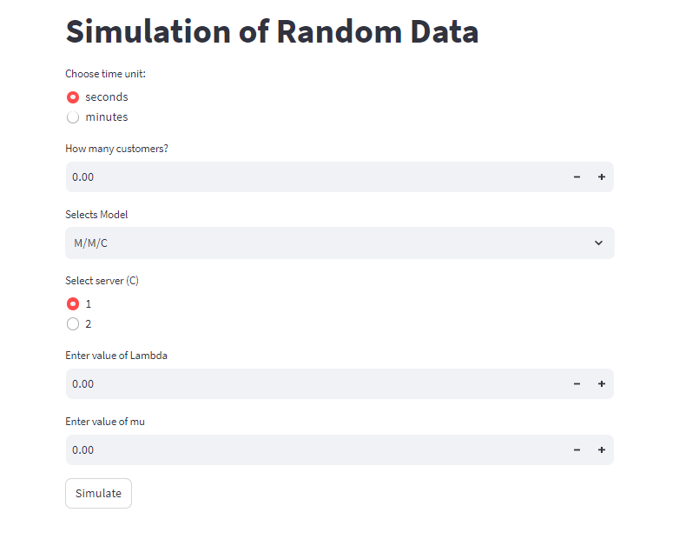

**2.3 Executing the Simulation:**

By clicking the "Simulate" button, users trigger the simulation process. The system processes inputs and generates comprehensive output metrics.

**2.4 Interpreting Simulation Outputs:**

Users gain insights through various outputs, including:

* **2.4.1** Cumulative Probability and Lookup: Cumulative probabilities and lookup values.
* **2.4.2** Interarrival and Arrival Times: Time intervals between arrivals and the actual arrival times.
* **2.4.3** Service Times: Duration of service for each customer.
* **2.4.4** Start and End Times: Service initiation and completion times.
* **2.4.5** Turnaround, Wait, and Response Times: Key time intervals for customers.
* **2.4.6** Average Performance Metrics: Mean values of service, turnaround, wait, and response times.
* **2.4.7** Server Utilization and Idle Rates: Efficiency metrics for server utilization.
* **2.4.8** Gantt Chart Visualizations: Visual representation of service timelines.

1. Example: **Simulation of Random Data M/G/1 (Single Server) in Minutes**

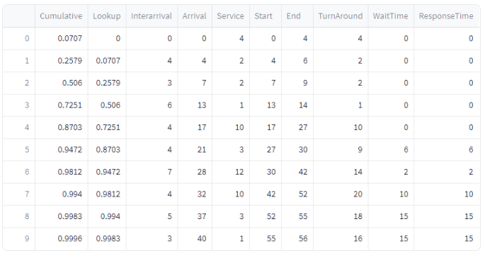

* **Result & Gantt Chart:**
* 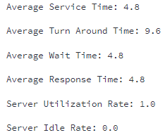**Result & Gantt chart**

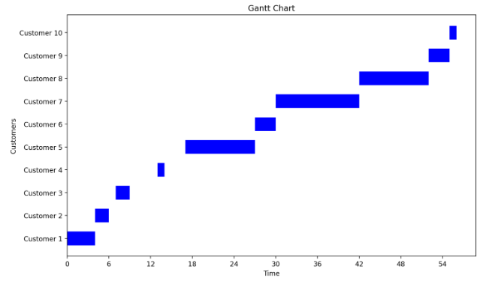

1. Example: **Simulation of Random Data M/G/1 (Single Server) in Seconds**

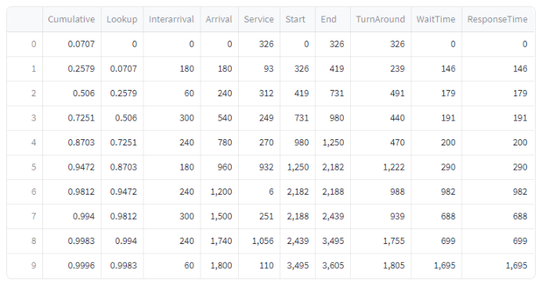

* 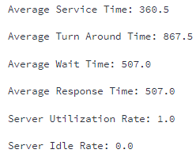**Result & Gantt Chart:**

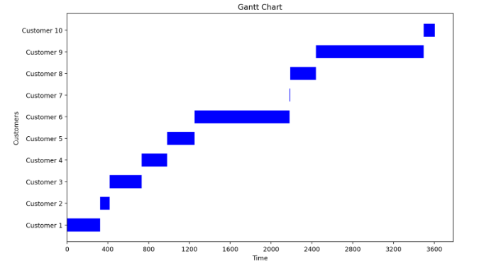

Example: **G/G/2 (2 Server) in Minutes**

1. Example: **Simulation of Random Data G/G/C (2 servers) in Minutes**

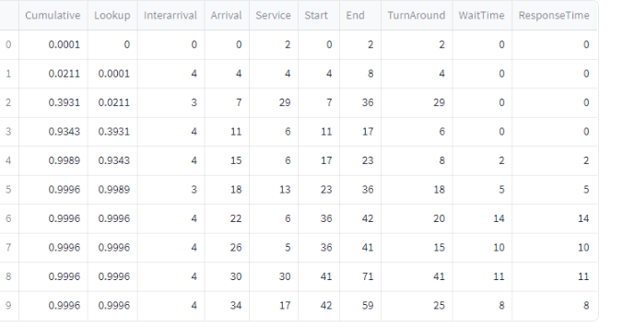

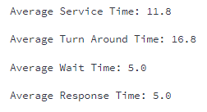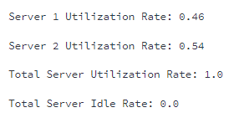 **Result: Server Utilization**

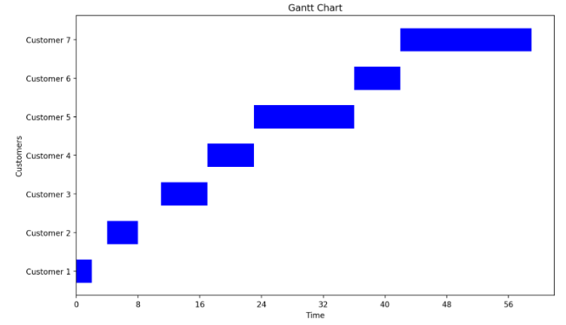**Gantt Charts for Server 1 & Server 2:**

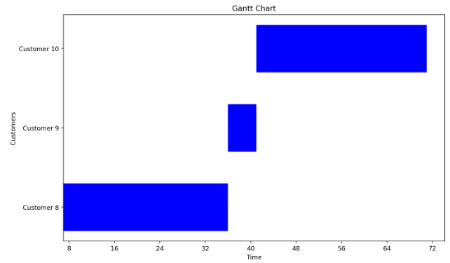

**3. Queuing System:**

**3.1 Understanding the Queuing System:**

The Queuing System section explores the performance of various queuing models. Models available include M/M/1, M/G/1, M/G/C, and G/G/1. This section delves into server utilization, customer wait times, and other crucial metrics.

**3.2 Configuring Queuing Models:**

Users customize their queuing system exploration by:

- 3.2.1 Model Selection: Choosing from available queuing models.

- 3.2.2 Input Parameters for Chosen Model: Inputting model-specific parameters as needed.

* **Queuing System Page (Screen Shot)**

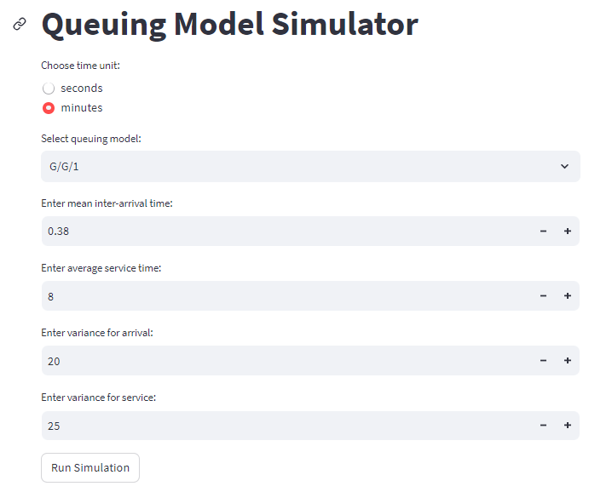

**3.3 Initiating the Queuing Simulation:**

Upon clicking "Run Simulation," the queuing model simulation begins. The system processes inputs to generate insightful metrics.

**3.4 Analyzing Queuing System Outputs:**

Outputs encompass:

* **3.4.1** Server Utilization Factor: Fraction of time servers are active.
* **3.4.2** Server Idle Time: Time servers remain inactive.
* **3.4.3** Customers in Queue and Wait Time: Number of customers in the queue and their wait times.
* **3.4.4** Customers in the System and Wait Time: Total customers in the system and their wait times.

Example: **QUEUING G/G/1 MODEL (In Minutes)**

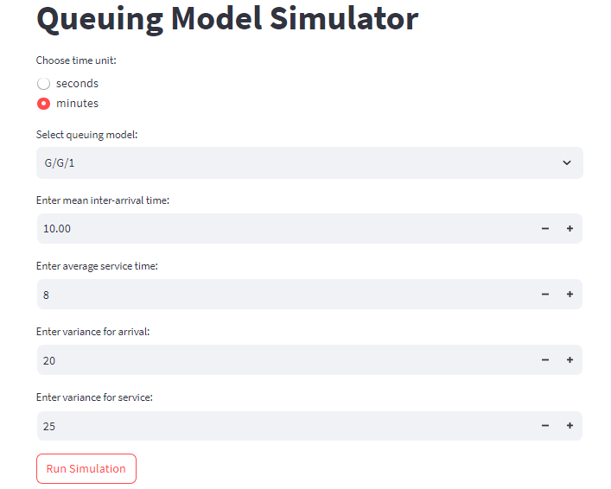

**Result:**

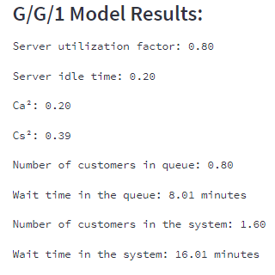

Example: **Queuing M/M/2 Model (In Seconds)**

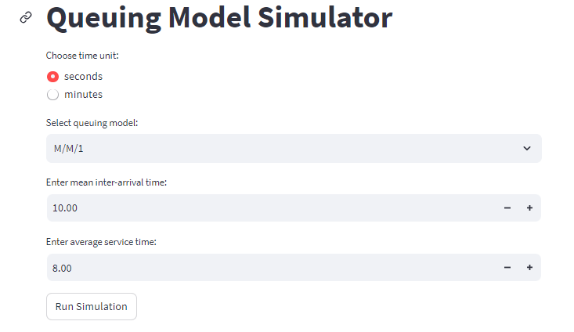

**Result:**

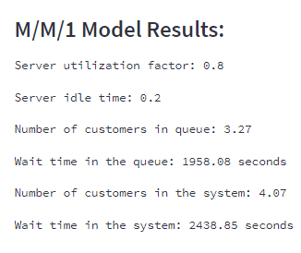

**Used Libraries to build this project:**

* Streamlit
* Pandas
* Matplotlib
* Math
* Random

**SUMMARY:**

In summary, using the Operational Research Simulator Project with busy servers and zero idle time provides benefits such as optimal resource utilization, enhanced efficiency, improved customer service, cost savings, effective staff planning, proactive decision-making, continuous improvement, and risk mitigation. By leveraging the simulation capabilities, you can optimize the queuing system's performance and ensure a seamless and efficient operation.

**CONCLUSION:**

The Operational Research Simulator Project is a comprehensive web-based application that allows users to simulate and analyse the queuing system of a Sheikh Zayed Petrol pump. By providing various data analysis, visualization, and modelling functionalities, the project facilitates decision-making and optimization of the petrol pump's operations. Users can explore different scenarios and understand the performance metrics associated with the system

This documentation empowers users to engage in meaningful simulations, interpret outputs, and make informed decisions.